ANNUAL REPORT 2021-22
St John the Evangelist
Hurst Green, May 2022

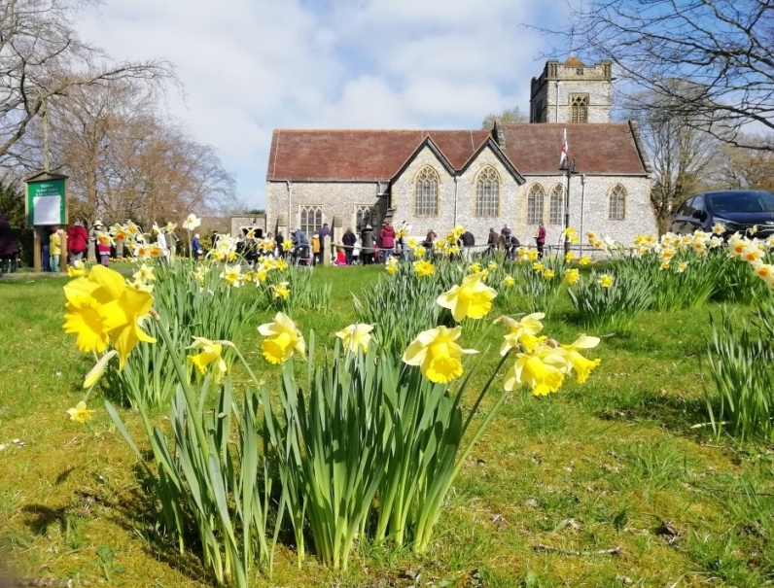

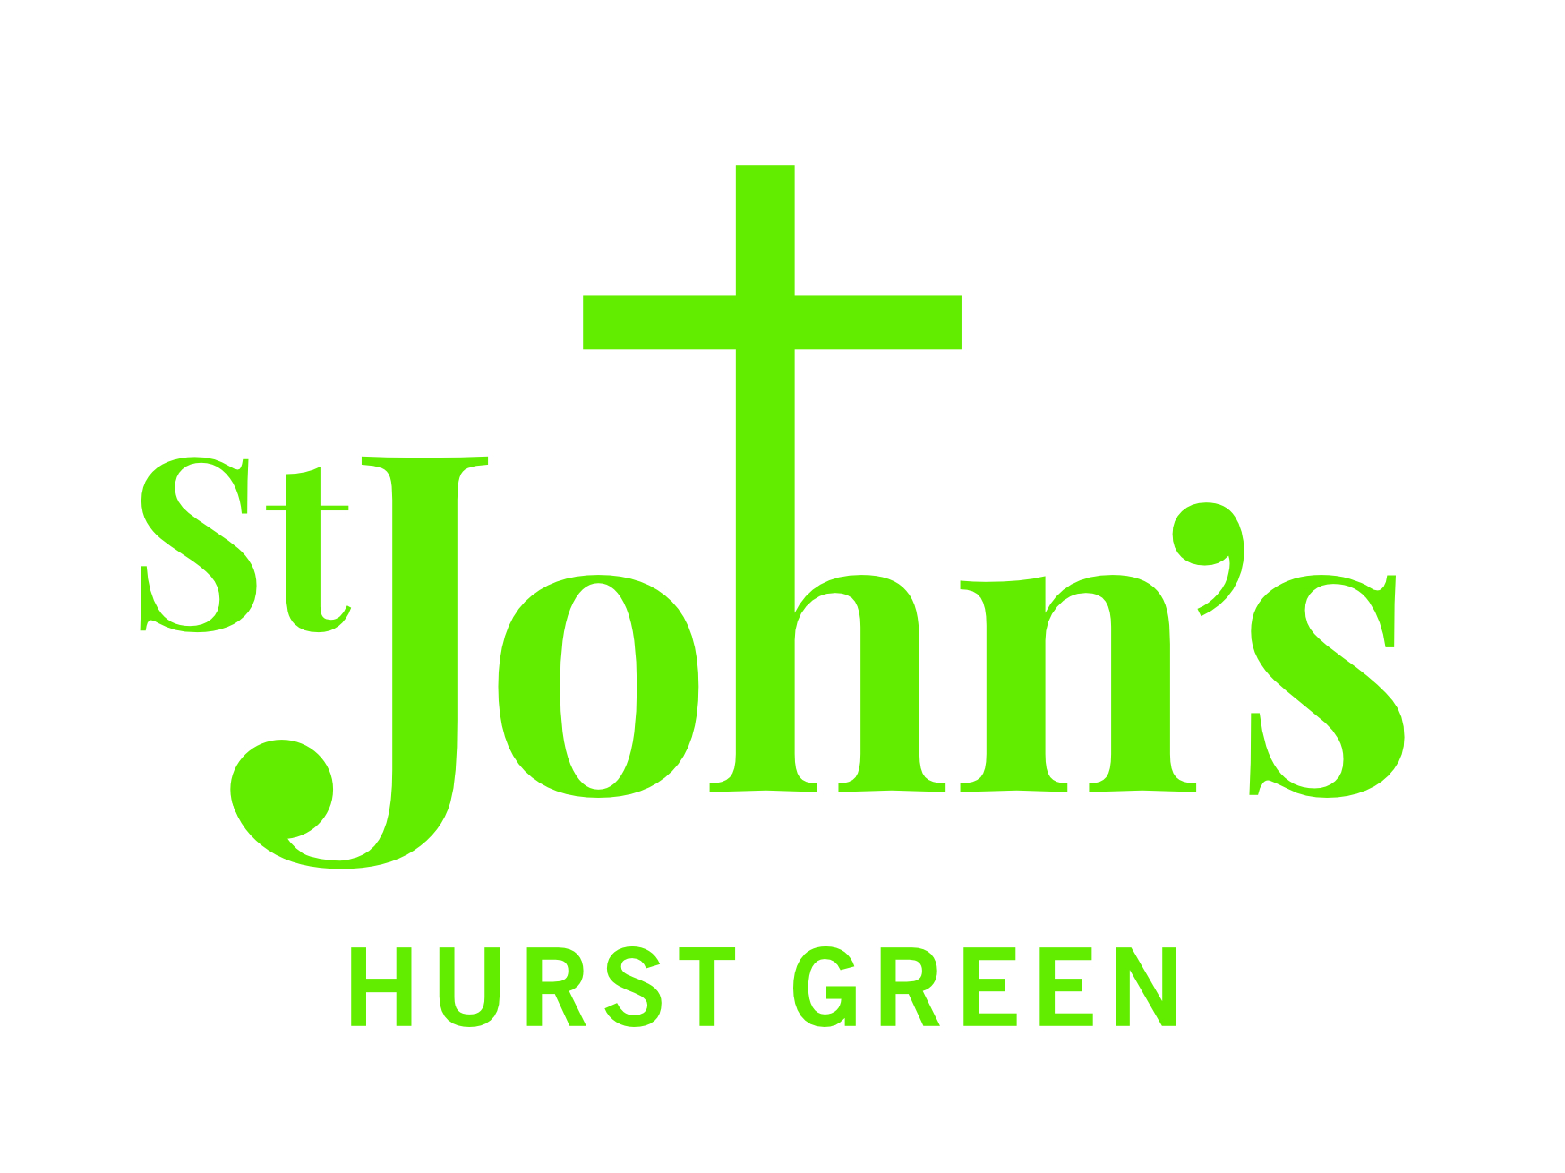

Rector and Ministers’ Report
"The rain came down, the streams rose, and the winds blew and beat against that house; yet it did not fall, because it had its foundation on the rock." Matthew 7 v 25

This year the storms and challenges have continued to beat against us and in some ways our life at St John's has been more uncertain and unpredictable than the year before. The 2020-21 Annual Report describes how we rose to the challenge of many months of Lockdown and spent a majority of the year worshipping together as the Oxted Team through our creative YouTube services and reaching out to one another in our homes in special ways as restrictions allowed.

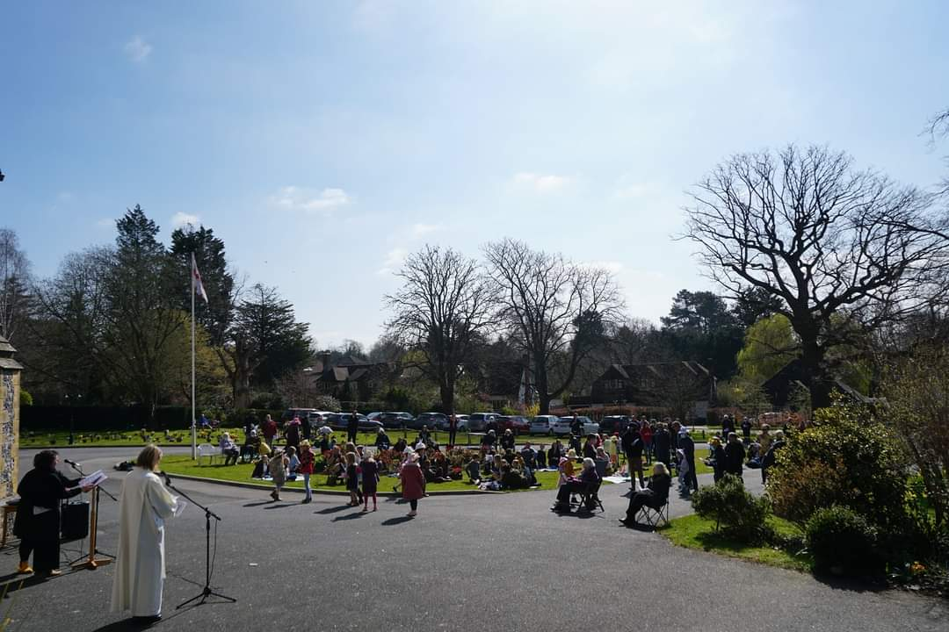
We continued to enjoy Oxted Team YouTube services until June 2021 but began to hold outdoor services too, the most wonderful being the outdoor Easter service when on a glorious sunny day a great crowd of people gathered at St John's and through drama and joyous singing and music we celebrated the hope of new life through the resurrection of Jesus.

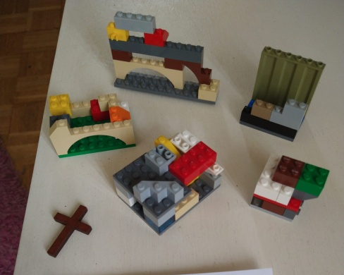
Then at the start of June we began worshipping indoors at the new times of 8.30am and 9.45am and sharing Holy Communion, in a COVID-safe way, once more, streaming services as often as we could. We have had to be creative again but in less obvious ways. For example many people were still cautious to return or seized the moment to step back. Like many organisations we found ourselves with fewer volunteers and so encouraged families and young people to serve in new ways and step into roles they may not have considered before such as sidespeople and servers. In other words we turned challenge into an opportunity. The same can be said for the smaller number of Sunday School volunteers. Now on the 3rd Sunday of the month we have an 'All Together' service. This means there is one less Sunday to run Sunday School but instead we more intentionally involve our children in the service in church through reading or praying. It seems that this transformation is what Jesus did too - water to wine, blindness to sight, death to life.

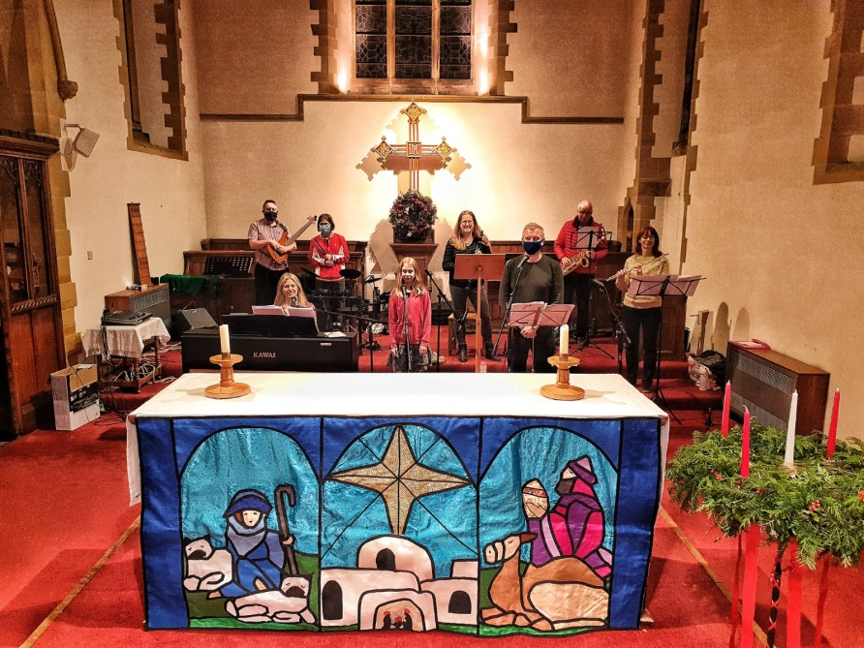
By September things were much more hopeful and we were worshipping in church with fewer restrictions. We had a Climate Change service and 'Send a Cow' Harvest, All Souls and an outdoor Remembrance Sunday. Then Covid rates rose in December and Christmas plans were adjusted and changed. Again a challenge became an opportunity when clergy and ministers expressed caution about the Christmas Eve crib services but Sarah Belton and the café church band rose to the occasion and provided two wonderful services for families.

Throw into the mix pretty much the whole ministry team getting COVID at some point during this year and the rector's absence for major heart surgery and you will begin to see what a difficult and uncertain time it has been for everyone! This year we also said goodbye to Neville Jacobs who moved to be with family in the West Country and have shared sorrows with Charles as his dear wife Janet died. Mark Anderson, team curate, also moved away to a parish near Winchester but it has been good to continue to minister with James Ashton and others from the wider team.

God is in the messiness and muddle and somehow we came through. I believe that credit goes to no one person in particular but thanks are due to all - congregation, lay ministers, churchwardens and clergy - who have all stepped in and stepped up. We managed to re-start old favourites such as the coffee morning and YoYos and even began some new things which you'll read about in this report.

As we returned to in person worship we've also been inundated with baptisms and Lotwina has enjoyed taking these and getting to know local families.

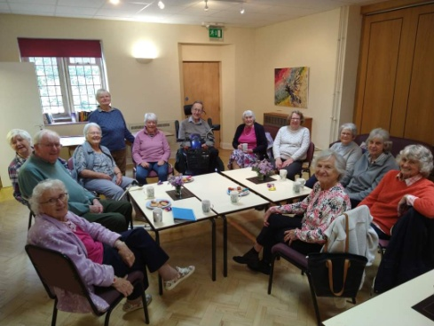
The year ended with Lent which included Lent lunches, a fairtrade stall and visiting speakers and a 'proper' Holy Week and Easter for the first time in three years. Like the man who built his house on the rock we have discovered our Rock never fails us and whatever uncertainties and storms we face we remain people of faith and hope. This applies to us as much as individuals as to the church. So let's hope and pray 2022 will be a calmer year than last, that the sun will shine and the future become clearer and more certain.
Revd Canon Anna Eltringham, Rector Oxted Team

Churchwardens’ Report
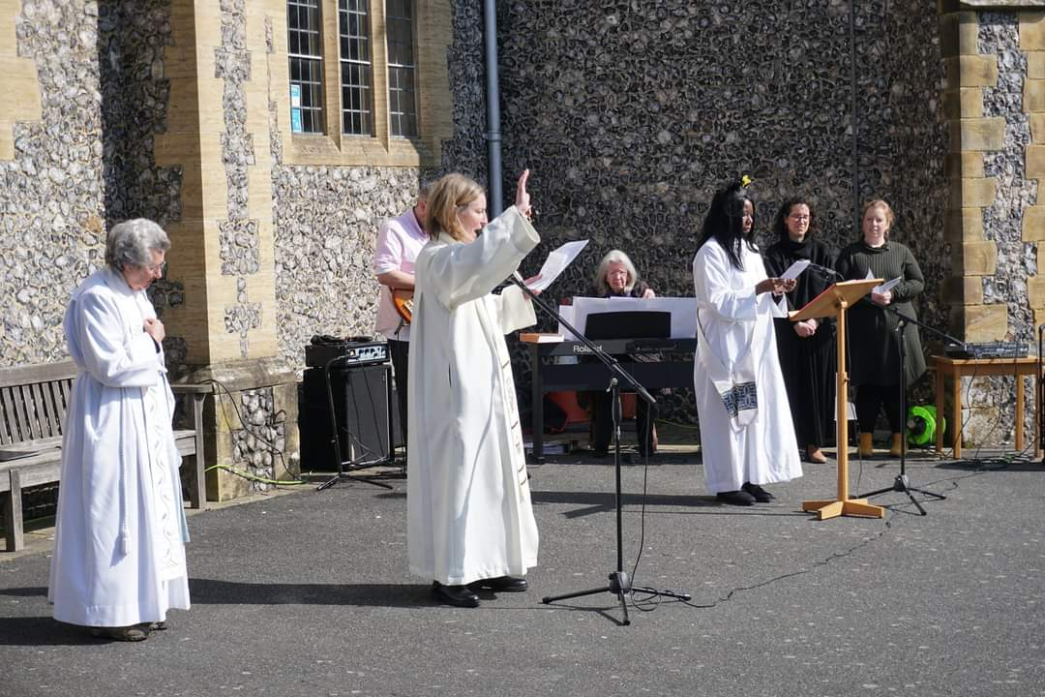
The last year (May 2021 - April 2022) has again been rather unusual as we started to return to “normality” while still living in a pandemic. We resumed Communion Services in May 2021 and it has been particularly lovely to be able to celebrate major festivals such as Harvest, Christmas, Mothering Sunday, and Easter, with congregational singing, in the church. Services are still streamed for those who are not able to come to the church in person.
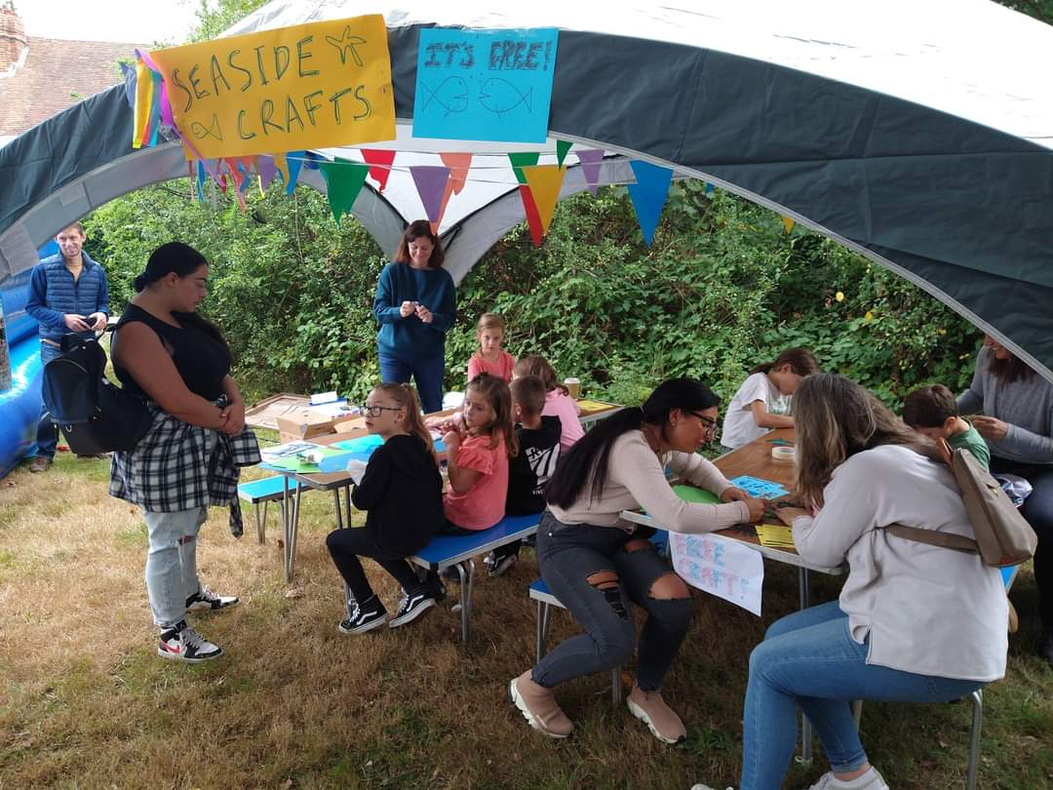
We continue to connect with the local community and at the Hurst Green Village Fair, we hosted a “by the seaside” experience comprising bouncy castle, coconut shy, puppets and arts and crafts for the children. We were also able to resume our coffee mornings and Yo Yos.

Lotwina was ordained as a priest and presided at her first Eucharist in July and in November 2021, Anna had heart surgery, which thankfully went well, and she returned to us at the end of January 2022.

In November, we said fond farewells to Neville Jacobs, John Mills and Ruth who all moved to be closer to their families. John had been a member of St John’s for over 50 years and a former churchwarden.

We would like to thank everyone who does so much work on behalf of St John’s. Anna, Mary, Lotwina, Charles, Wendy and Monica, those who serve on the PCC, look after our church admin and finances, sort out the recording for our online services, clean, arrange flowers, provide us with beautiful music, provide refreshments, prepare the church for services, look after the grounds, the servers, the crucifers, the sidespersons, the intercessors and many more.
Cathy Booth and Henk van den Berg
Fabric

In addition to the regular servicing and certification, various repair and maintenance jobs were required during the year, including:

- The lightning conductor rod on top of the Tower was found to be adrift. This necessitated hiring a steeplejack-enabled contractor to repair it.
- A significant mains water leak occurred towards the end of the year. Our insurance company was notified and arranged for the repair work to be carried out. It appears that the leak was beneath the York Rooms and hence inaccessible, so the contractor bypassed that part of the water main and installed a new length of pipe alongside (outside) the York Rooms. We are still awaiting a decision from the water company (SES Business) regarding the potential for charges against water ‘lost’ during the leak.
- Final details and approvals were agreed to go ahead with the York Rooms redecorating (which then occurred in Jan 2022).
- The church microphone system, especially the lapel mics, began to be unreliable and progress was made in ordering a new set of microphones and their control system. This was installed early in 2022.
- Enquiries were made towards setting up a bespoke camera system in the church to allow more efficient streaming of services etc. This work is scheduled for April/May 2022.

The Quinquennial Inspection took place in July; this is a 5-yearly inspection of the church building on behalf of the Diocese. The Report, issued late in the year, recorded no major items but there were minor issues, including:

- Fitting new hinges to the access door onto the tower roof
- Providing a system to stabilise the ladder used when accessing the York Rooms’ flat roof
- Local re-pointing of various areas around the outside of the church
- Adding colour differentiation (ie. paint or ‘tape’ to the edges of the main entrance steps (to make them stand out more).
Chris Johns

Finances
Finances

Headlines for 2021
For the full accounts please see the Appendix at the back of this report. But read on here for a summary of 2021 and what we can expect for 2022…

2021 represented the second year in which we had to live with the effects of the Covid-19 pandemic. However, with fewer lockdowns and restrictions it was possible to resume hall and room hires for most of the period and Hurst Green News had a full year of publication, so Activities for Generating Funds saw a rebound to £23K (2020: £16K). Similarly, Statutory Fees Retained for weddings and funerals saw an increase to £3K (2020: £1K) as these could be held in church again.

Planned Giving was little changed at £68K (2020: £69K) but Other Giving was down significantly at £9K (2020: £15K) as the generosity seen in the early days of the pandemic was not repeated in 2021.

Grants income also saw an increase to £17K (2020: £13K) with Diocesan mission grants (£4K) and Tandridge District Council business restrictions grant for St Agatha’s (£9K) offsetting a fall in Covid Employment Retention Grants to £4K (2020: £7K) with Furlough winding down then ending.

Overall, there was therefore an increase in income to £141K (2020: £136K).

The PCC decided that our largest single item of expenditure, our pledge to the Parish Support Fund, could be maintained at £63K, though other Mission Giving from our own funds declined to only £0.3K (2020: £2.2K). However, this doesn’t include £2.3K (2020: £1.1K) passed directly to good causes from appeals.

Other PCC running expenses were little changed at £32K (2020: £31K), while Major Repairs & Improvements declined to £12K (2020: £24K). 2020 saw significant expenditure on the church and St Agatha’s, but this year did see £5K on York Rooms roof repairs and wall re-rendering and £6K on St Agatha’s guttering and external wall repairs.

Overall, expenses fell to £132K (2020: £141K).

With an inclusion of Investment Gain on the value of the Win Marnell Fund of £1.3K (2020: gain of £0.6) the PCC showed a surplus of £11K, compared to a deficit of £(4)K in 2020. Net Funds therefore grew to £119K, up from £108K at end of 2020.

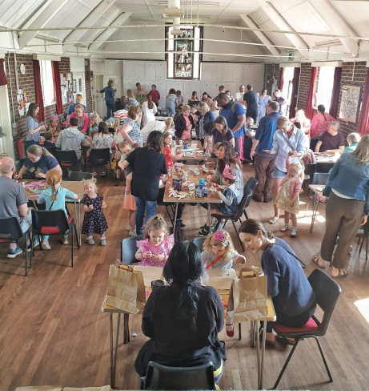
Looking forward to 2022
With the easing of the pandemic the Finance Committee assumed a return to almost full hire for St Agatha’s and more modest increase for Church Rooms. Giving income is assumed to be similar to 2021 levels but no Grant income is included, though Diocesan applications may be made and granted during 2022.

Within expenditure, the PCC pledged a 2% increase in Parish Support Fund to £64K. A provision of £9K for church repointing and roof repairs and possible replacement of high-level smoke detectors is included, and £10K for audio and camera systems, part of which is already spent and will anyway be covered by pledges and a legacy.

The overall result is that, with the information available at the time when the budget was set in Feb 2022, there will be a deficit of £(1)K for the coming year.

Also for 2022, I wish to welcome Helen Ainsworth as our new Regular Giving and Gift Aid secretary, and ongoing thanks to Alison Richardson as St Agatha's Treasurer and running the Hurst Green News invoicing and chasing the debtors.

We rely on your kind donations for ¾ of our total income, and regular giving is very valuable to us and helps give us certainty in uncertain times. If you feel able to and have not signed up to our Parish Giving Scheme, I strongly urge you to do so. Please see more about it at https://bit.ly/StJHGGiving
Thank you!
Julian Taylor, Hon. Treasurer

Formalities and Legalities
The Parochial Church Council (PCC)
During the last year the PCC has met five times, in the evening with the day of the week being varied. The PCC is the legal governing body of a parish and, together with the Rector, makes decisions on every aspect of church life: mission, worship, children and youth, finances, buildings and grounds. There are currently 23 members.

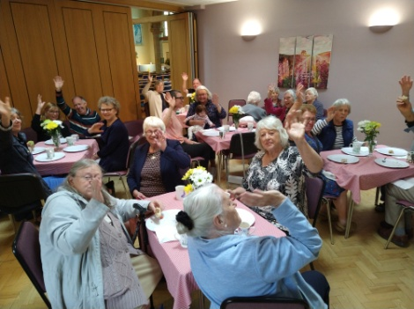
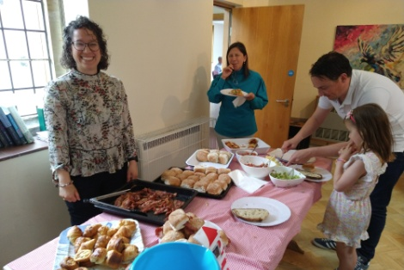
Subjects covered over the year include: the pattern of services, rebuilding community, volunteers, upgrading the sound system, filming equipment, emerging from Covid, ‘Crossing the Threshold’, Oxted Team youth worker, the church organ, Jubilee celebrations, new ways of supporting Christian Aid and the Children’s Society, in response to changing behaviour patterns in society, and keeping Hurst Green News in print. Regarding the photocopier, suffice it to say, the one eventually purchased makes excellent copies, more quickly, without paper jams and should be cheaper in the long term.

Since 9 March 2020 all meetings have been on Zoom. Some members elected during the pandemic were becoming quite excited at the prospect of seeing others ‘in the flesh’ instead of on a screen on 17 March 2022. Sadly this was not to be; with rising cases and anxiety, the decision was taken just hours before the meeting to revert to Zoom.

If you would like to be part of these conversations, please consider standing for one of the four 3-year vacancies on 22 May 2022. It’s also a good way to get to know other members of St John’s you would not otherwise come across at church. We hope the next meeting, on Tuesday 21 June, will definitely be in the York Rooms.
Janet Harman, PCC Secretary

Electoral Roll
In 2021 a figure of 142 was reported at the APCM. Following revision of the Roll for this year’s APCM, the figure is now 144.

Tandridge Deanery Synod
Stretching from the edge of Croydon to the southernmost parishes in the Diocese, bordering West Sussex, Tandridge is the newest, largest by area and most rural Deanery in the Diocese. A Deanery is a group of Church of England parishes in a geographical area. Deanery Synods, its formal meetings, provide a link between parishes, the Diocese and wider Church. Tandridge Deanery Synod is led by Area Dean, Revd Michelle Edmonds (on sabbatical leave until August); Assistant Area Dean, Revd James Ashton and Lay Chair, April Alexander, who succeeded Sue Mallinson after 10 years in the role.

There are three meetings a year. In June 2021 there was an introduction to the Living in Love and Faith materials with which all parishes were encouraged to engage. In October, Revd Sandra Schloss presented the Southwark Anti-Racism Charter and its implications for parishes. Helen Ainsworth, joined the meeting in February, to speak about her experience of the General Synod as a new member, elected in November 2021. A Deanery Arts Festival is proposed for 2023. Several members are actively involved with RASJF, raising awareness of modern slavery.

Currently there are 73 Deanery Synod members: all licensed clergy and elected lay members from each parish, the number based on Electoral Roll figures. St John’s is entitled to four but has just one. New representatives will be elected in 2023. The next meeting is at St Mary’s, Oxted on 14 June. Joining the Deanery Synod enables members to connect with other churches and feel part of something bigger.

Safeguarding
Both safeguarding officers have renewed their Safeguarding Leadership training (C2), as has churchwarden Cathy Booth, and the clergy are also up to date with their training. Many others in the congregation have completed Basic or Foundation Training. A safeguarding culture within our churches is still the emphasis given in training, and we continue trying to make safeguarding awareness an issue for all.
Sue Fox and Cathy Hyde, Parish Safeguarding Officers

Health and Safety
Covid-19 continued to dominate our health and safety considerations over the last year and the situation continues to be monitored.
Cathy Booth, Health and Safety Officer

HR
There have been a few changes on the payroll over the last year. Janet Harman remains as Parish Administrator but has stepped down from Hurst Green News. Lucy Forster is the newly appointed HGN Editor / Producer. Kelly van den Berg continues as our Communication Officer and Lisa Hall is the Church Rooms and St Agatha’s Hall Booking Co- Ordinator. Hilary Dilnot is our Director of Music and Gillian Daniels has taken over as the Caretaker for St Agatha’s Hall. All other posts are voluntary and not paid.
Cathy Booth, Churchwarden

Vision and Mission
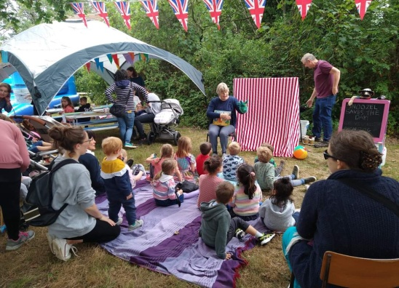
Early in 2021 the PCC discussed 'emerging from COVID' (even though we might say that is still in progress)! There was a desire and a need to re-connect and re-build and so efforts were made to put St John's back on the map at the Hurst Green Fair. Almost the whole stretch of hedge behind St Agatha's became 'St John's on Sea' - there were deck chairs, a sea themed bouncy castle and crafts, puppets, coconut shy and much more and it was clear to all that we are a thriving church in this community.

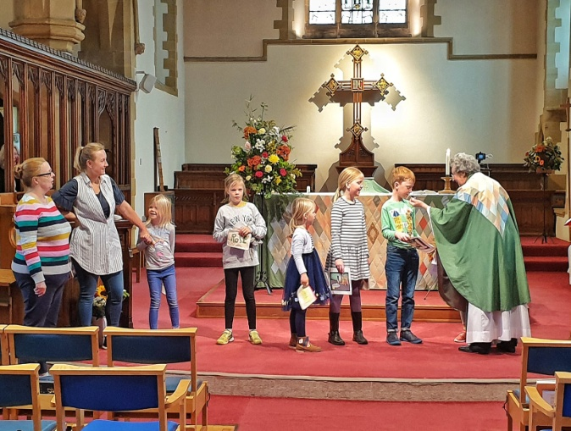
Throughout this year the need to reconnect and rebuild the community of St John's, while not lose sight of our subsequent vision post COVID to reach deeper into the local community than ever before, have somewhat been held in tension and go with us into the year ahead.

In late Spring 2021 the Rector asked various people to each draft a vision for St John's for a particular area of our church life such as children and youth, our buildings, worship, older people etc. These were reviewed and considered en masse and the following vision overall has emerged:

St John's: a church without walls, at the heart of the community, meeting people's needs with compassion and nurturing relationships with Jesus.

The detail behind this is not just about being more accessible from the outside in, but also breaking down barriers within the church too such as making it easier for people to join in with the music or enabling more lay people to be involved in leading our services (and some such things have already begun to happen).

As these thoughts and reflections came together it also felt necessary to consider how to make the St John's building and physical resources more accessible, flexible and sustainable too. A group called 'Crossing the Threshold' formed to consider and plan how we can help all sorts of people and groups access and use the building more as well as make it more flexible and accessible for our own use as a church too. Work has already begun in some areas such as de-cluttering vestries, marking out car parking for those with disabilities and reviewing signage.

But there is a lot still to think about and plan as this new business year begins and hopefully the worst of COVID is behind us. In some ways we have a blank sheet like never before and we need to think as imaginatively and creatively as possible. What sort of church does St John's need to be in the 2020s to share the love of God and good news of God's kingdom as widely as possible?

Church Life and Worship
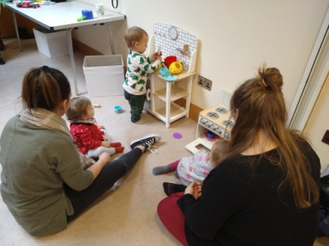
As already outlined, this last year has had its challenges. But as we find ourselves at the end looking back it is great to see that the likes of YoYos baby and toddler group and the Fortnightly Coffee morning are back and back in a big way. Both are still well attended (although the coffee morning regulars would like some more men please) and wonderful, inspiring and creative volunteers run both very successfully. It was also good to return to taking services at David Gresham House and Churches Together events and services too including hosting a Lent group in the York Rooms to study Tear Fund’s devotional booklet ONE to which Lotwina contributed.

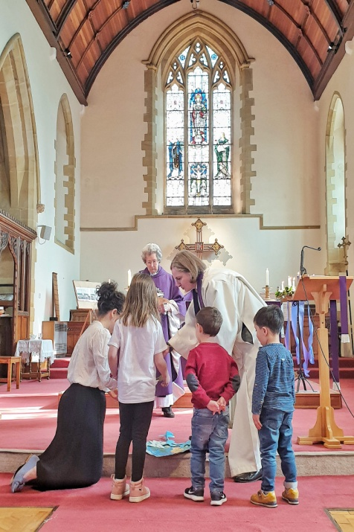
While some groups have returned to what they were, other things have been re-imagined. Sunday School is now twice a month and there are two services where everyone worships together. Sunday Munch for older children still meets on the second Sunday and we are hoping to recruit a part time youth worker, with a small amount of mission funding, very soon. As yet we haven't re-started any worship like Cafe Church as we consider what more modern and accessible forms of worship we now need and who and how we will run them. Also, as the streaming of services becomes more formalised, how do we make sure online church is wide-reaching too?

The musical side of worship has also developed in new ways. In early 2021 people were invited to share their thoughts on what they wanted to hold on to from Lockdown and what they hoped for in our worship and life at St John's as we returned in person. Our Director of Music also reflected on this and the ideas came together to create more varied worship each Sunday with a mix of music on the organ, piano and other instruments and a blend of traditional and more contemporary hymns and songs. The re-positioning of the singers in the main body of the church was in part to help the streaming of services but also to help and encourage the congregation's singing. Additionally, this re-location also seems to help some occasional singers feel able to 'drop in' every now and then. The new approach has been really appreciated although some miss a robed choir so for high days and holy days the choir still robe and lead our singing from the stalls.

Not only have some things returned and others been re-imagined, but new things have also begun. Singers from across the Oxted Team have been involved in Evensong at St Peter's and will contribute to other services. A group of people from different churches in the team also came together as a study group for the 'Living in Love and Faith' initiative created by the Church of England. An Eco group formed after the Climate Change service in September and have already led a service to involve the congregation in deciding our environmental priorities as a church and are now getting underway to address them.

There are shoots of new beginnings in our midst and lots of things we could potentially do and be. But ultimately God holds our future (as well as our past) and we must trust and be guided by him in the ways we should go. To do that let us continue to rejoice in 'being' in the present, meeting together faithfully week by week, praying and worshipping our loving God, open to his heavenly grace, peace and gentle leading.

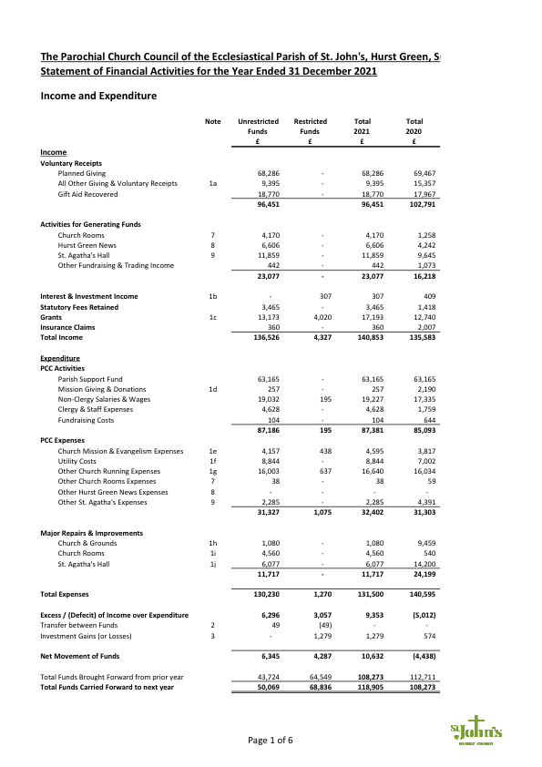
Accounts
